Github note 1

Tran Thai Hung

Last version: December 04, 2024

Abstract

Quick note to clone a repo and publish a branch.

Table of contents

# 1. Steps to Clone a Repository on GitHub

1. **Visit the GitHub repository you would like to clone**  
   For example: <https://github.com/OUCRU-Modelling/R-cafe>.
2. **Click on Code → select HTTPS → copy the link in the URL**.

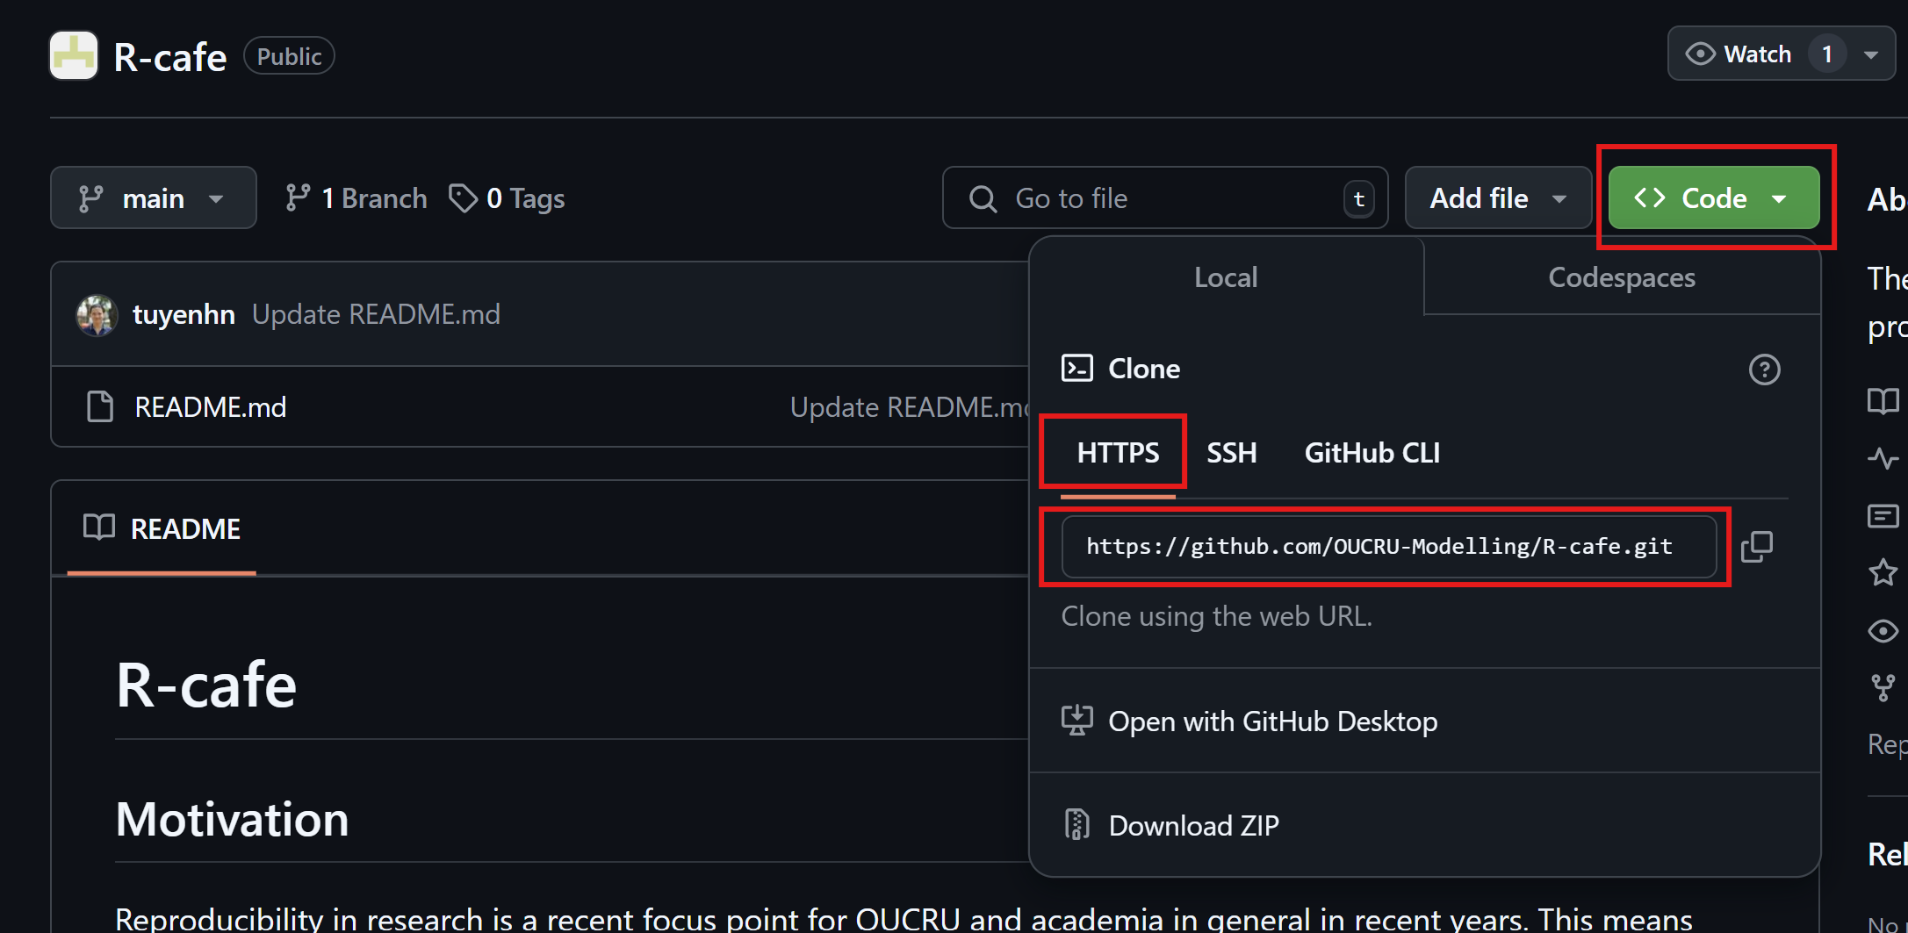

Copy the repository link

1. **Open GitHub Desktop**  
   Then choose File → Clone repository.

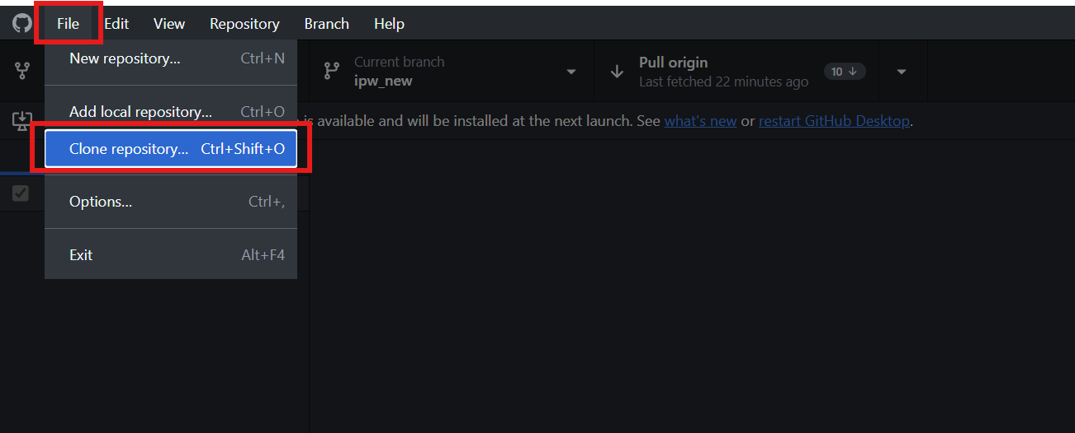

Open cloning tab

1. **Choose URL**
   * Paste the copied link into the blank field below “Hub/cool-repo”.
   * Change the local path to your preferred directory (or it will use the default directory).
   * Click Clone.

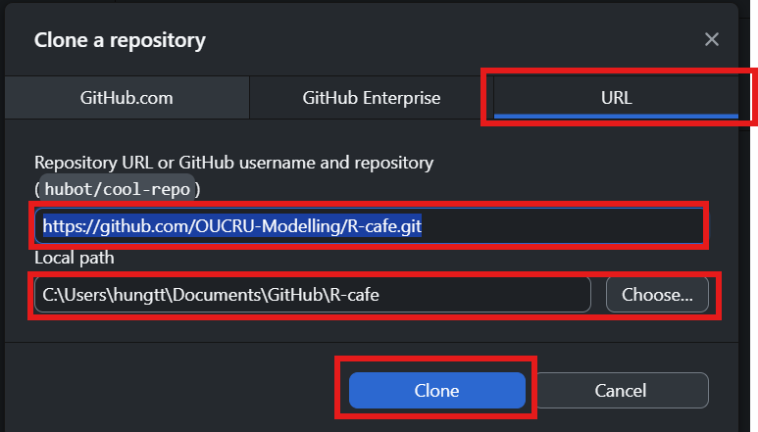

Paste the link

1. **Verify**  
   Check if the repository has been cloned to the correct location.

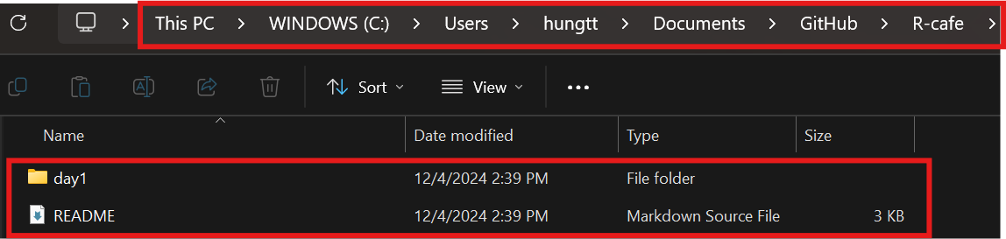

Check local repository

# 2. Steps to create a new branch

1. **Create new branch**
   * Click on Current branch (main) -> choose New branch

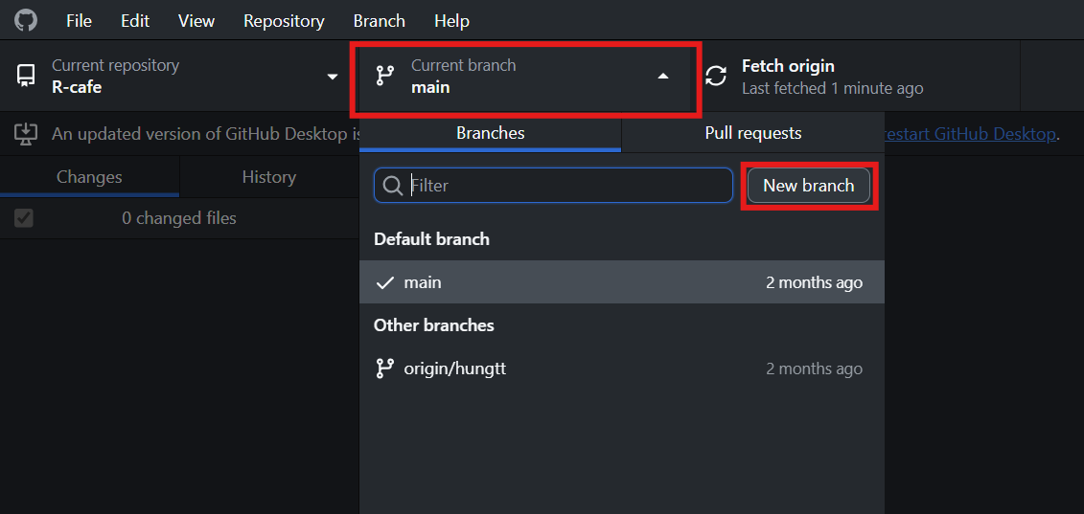

Create new branch

1. **Name the new branch**
   * Fill in the branch name (For example: “hungtt”) -> choose Create branch

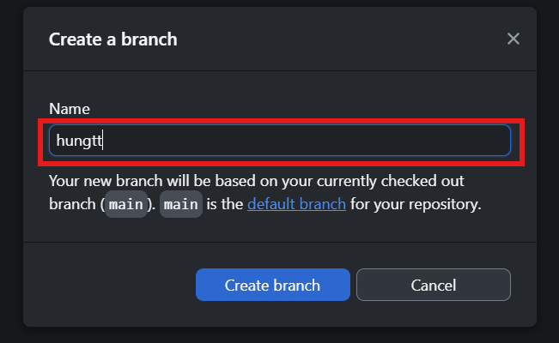

Name the new branch

1. **Publish your branch**
   * Click on Publish branch

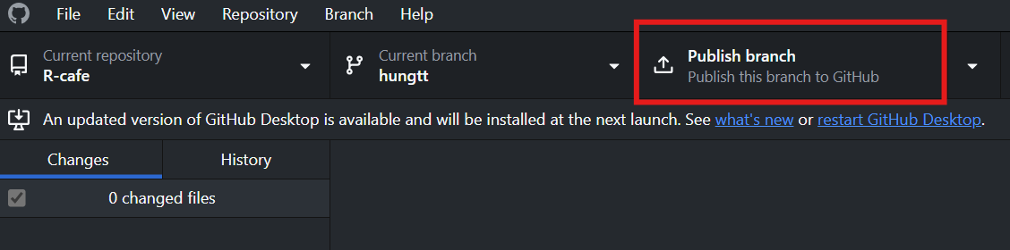

Publish branch

1. **Check your branch on Github**
   * Click on main. You might see your branch name. If not, choose View all branches to find your branch.

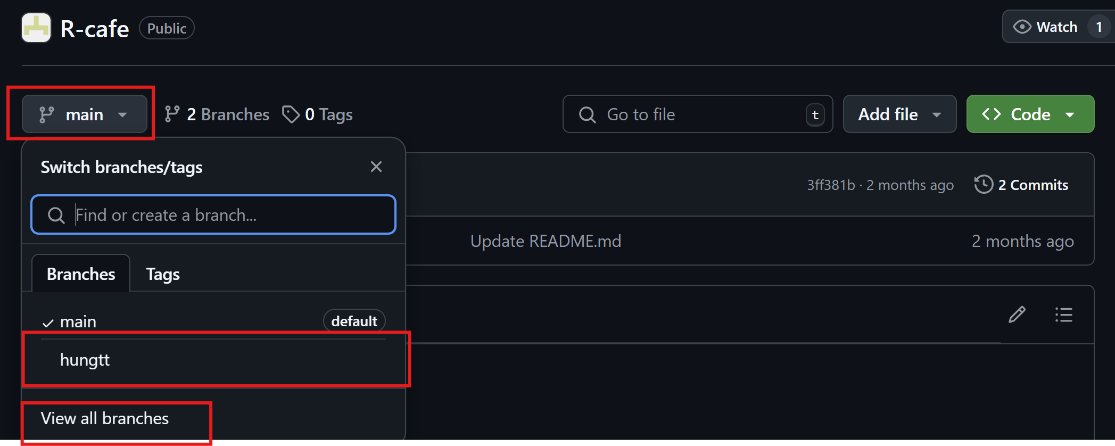

Find your branch